SmarBoard Lesson http://smarttech.com/trainingcenter/tutorials.asp#
Lesson on Geography and World Events - Maps
- Open Essential for Educations -
- Go to Geography – maps - World Outline
- Move the Continents onto the MAP
- Enter the text (keyboard or write) or save
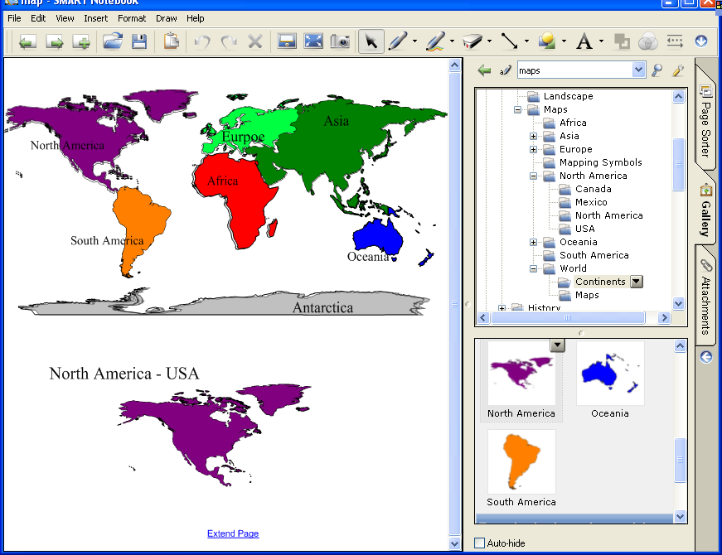
Note Write, ink of highlight the page
Write World Map and Convert to TEXT
Insert NEW Page for USA
- From Page Sorter - Highlight Notebook
- Insert a new page for North America
- Insert Menu
- Blank Page
- Gallery go to pick United States
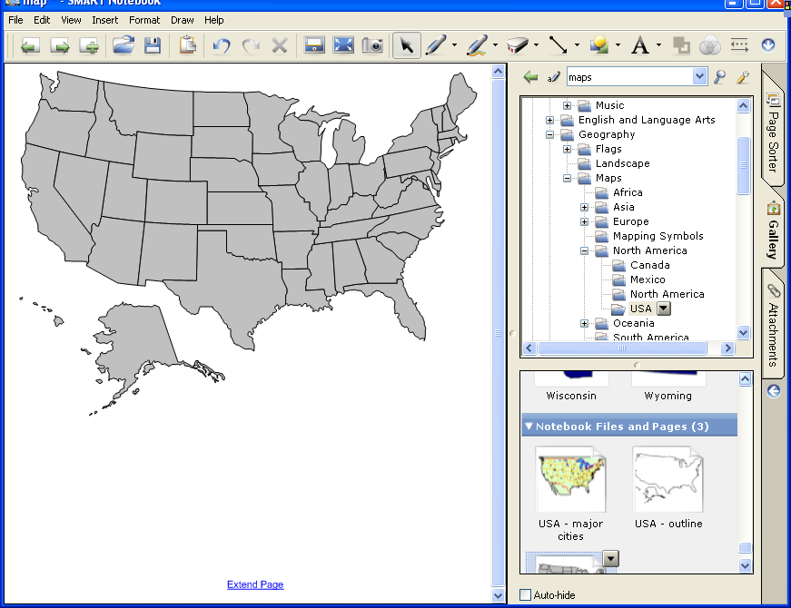
- Move above and drag the states onto the map
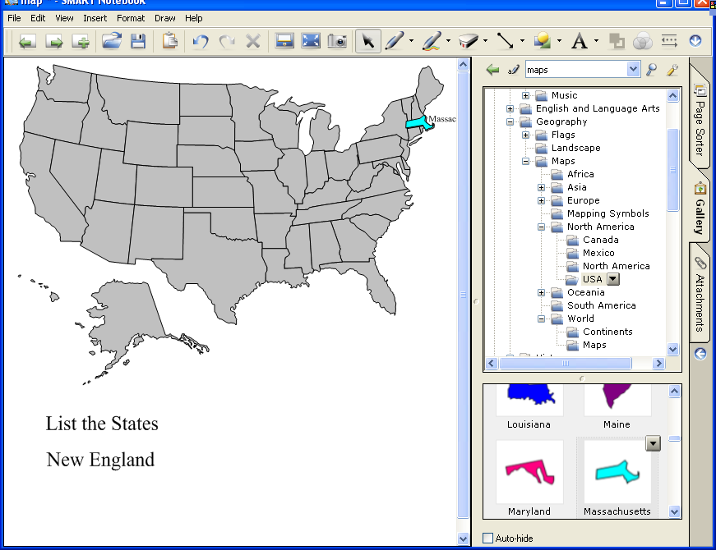

Finished Map of the USA
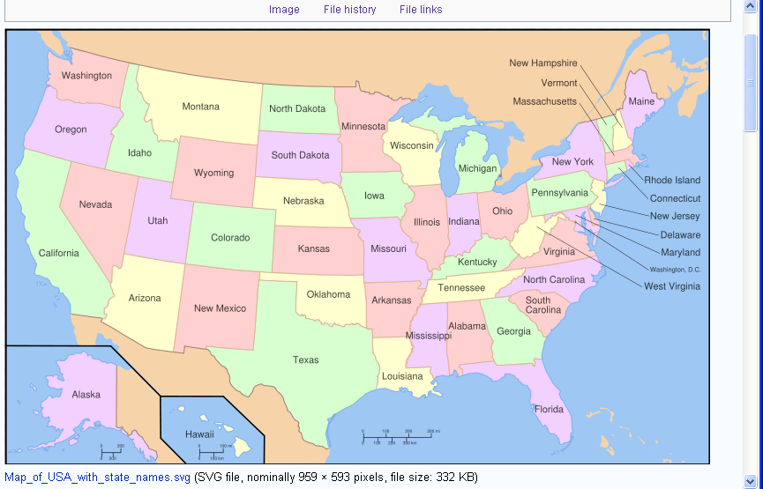

Scramble the States (hide lesson)
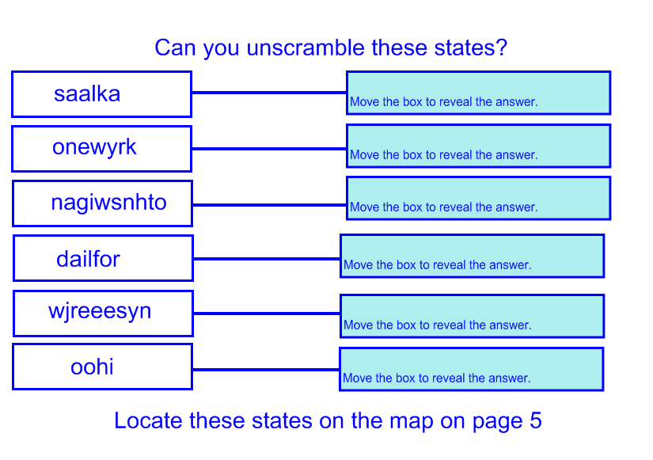
New England Lesson and Quiz Website http://www.enchantedlearning.com/usa/statesbw/newengland.shtml
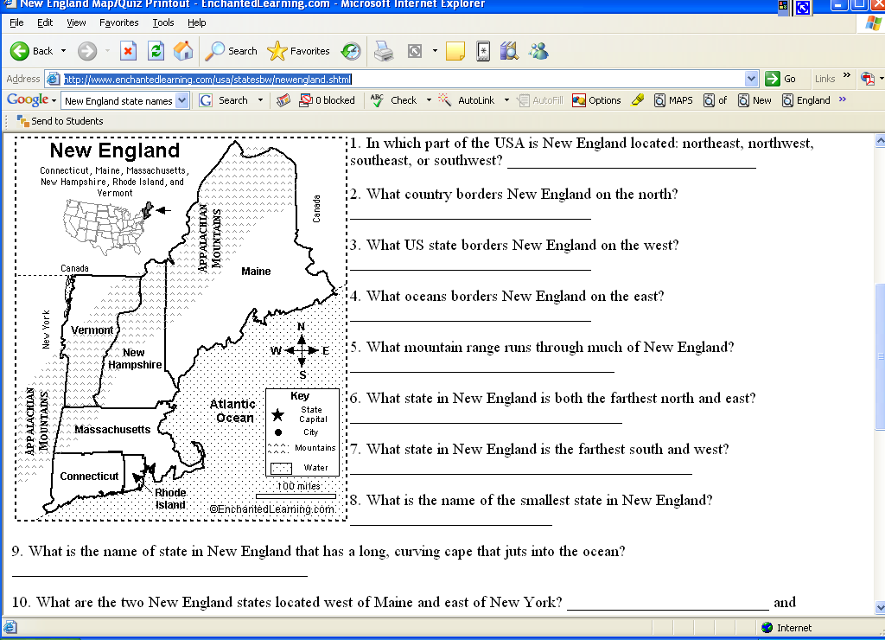
More on this type of lesson
http://education.smarttech.com/ste/en-US/Ed+Resource/Software+Resources/essentials/Geography/Maps/USA.htm
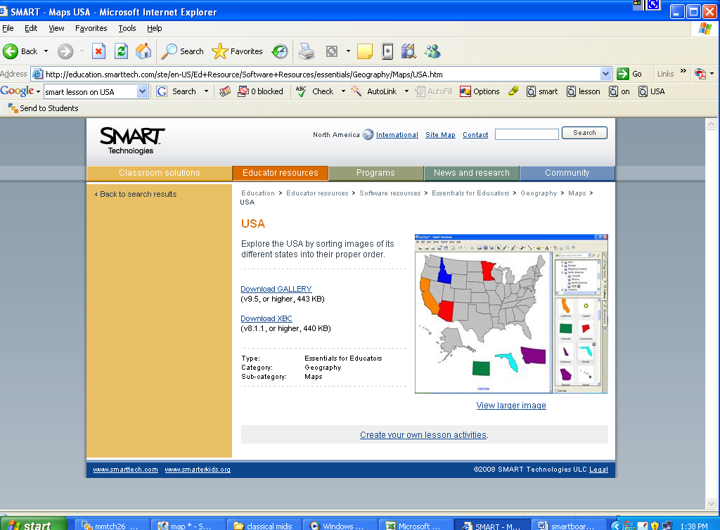
Lesson Extension http://education.smarttech.com/ste/en-US/Ed+Resource/Lesson+activities/Notebook+activities/Standards+Search+US.htm
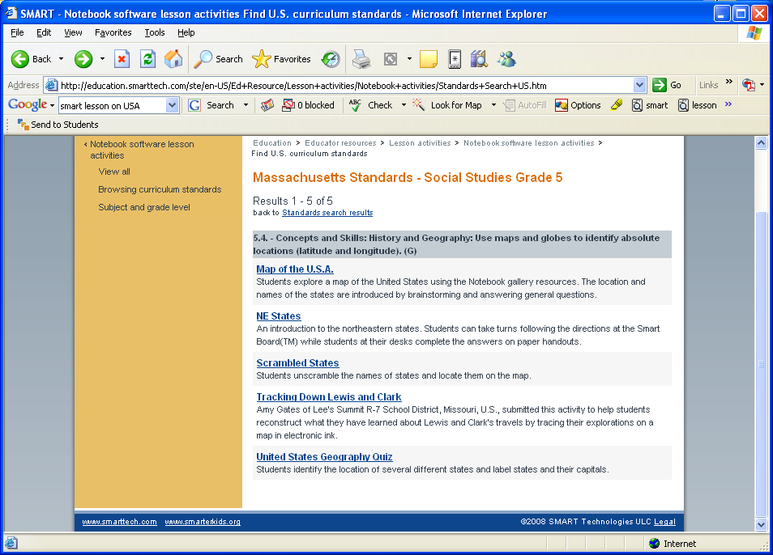
Scrambled States Lesson
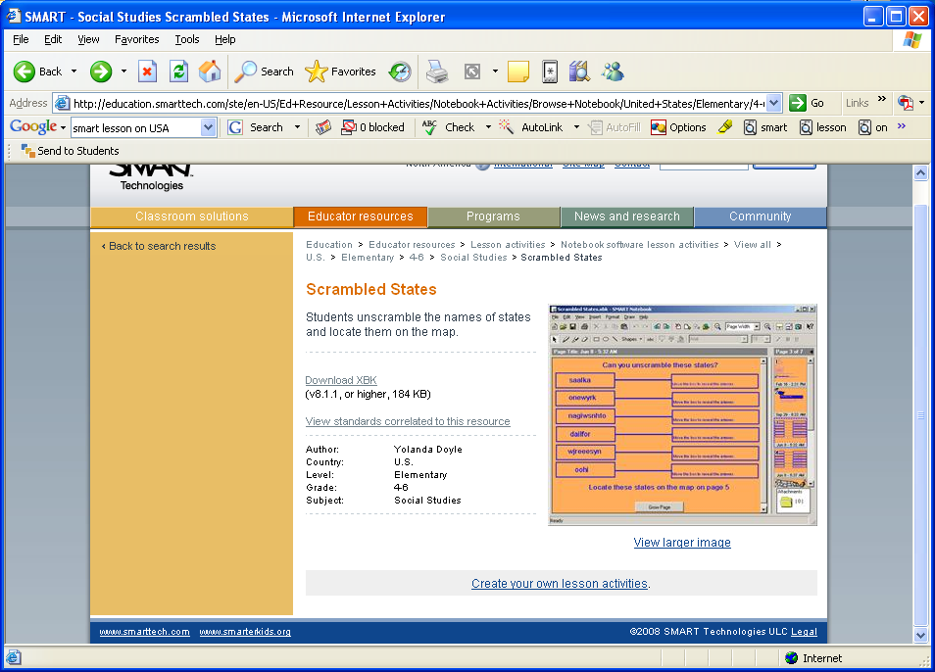

Links to Frameworks and lessons
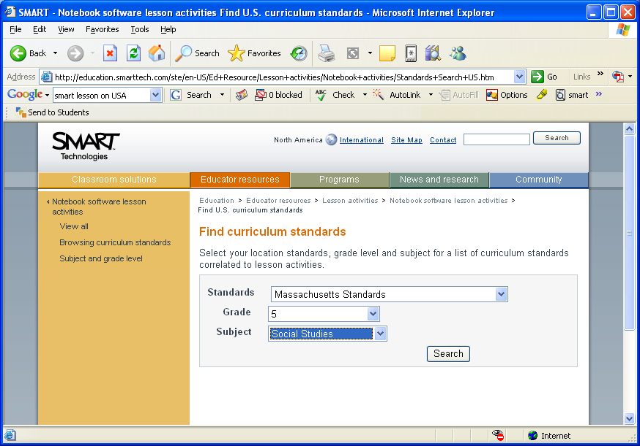
Lessons by Grade level

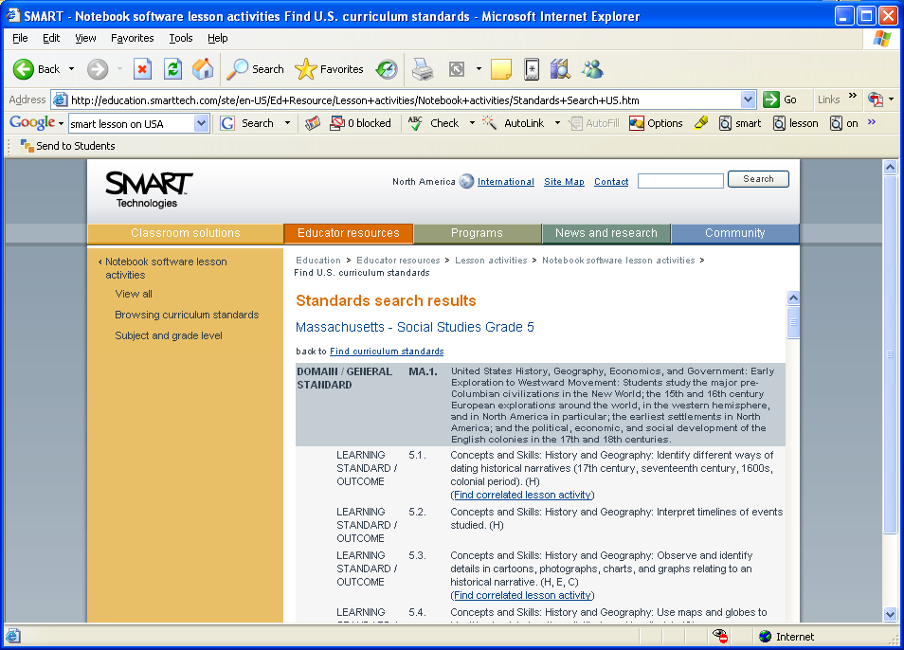

Middle School
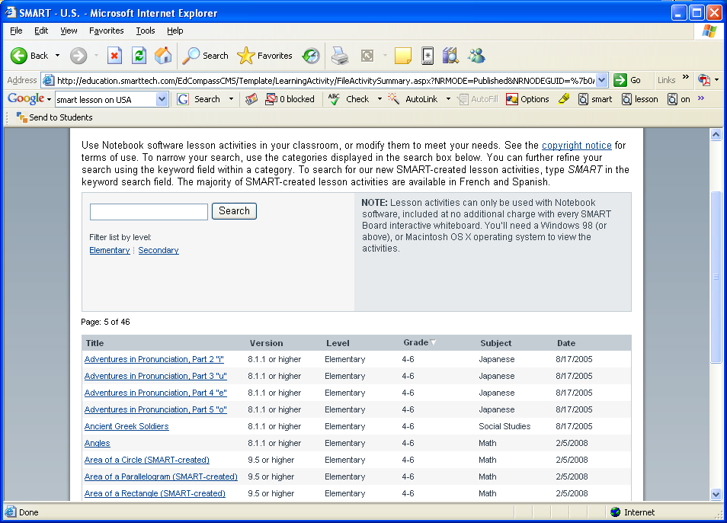

English Lessons
Lesson 1 on Idioms
Subject: Language Arts - Topic: Idioms
Title: Idioms: What Do They Really Mean?
Grade(s): 5 - 8
Cross-curricular link(s): Non- specific
Intended learning outcome(s)
· Identify and interpret the meanings of idioms in context
· Identify idioms to match definitions of the idiom
Write sentences using idioms
· Write definitions of idioms
· Write short paragraph that gives clues to what a specific
idiom means
Recommended usage: Whole group to teach or review idioms
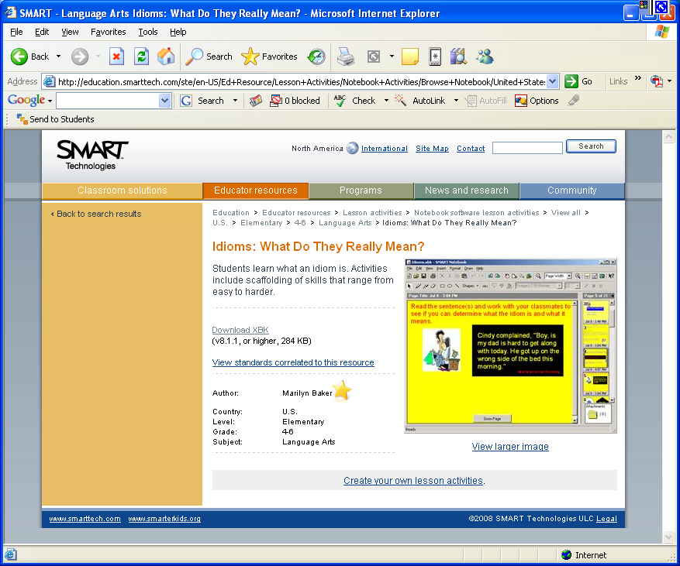

Lesson 2 on Idioms - matching
This lesson teaches the uses of idioms in everyday language. Matching games and re-writing sentences to include idioms are the activities.

Lesson 3
Idioms (Question Set) | View Standards

Use Senteo interactive response system to test knowledge about the use of idioms in everyday language and re-write sentences to include idioms.
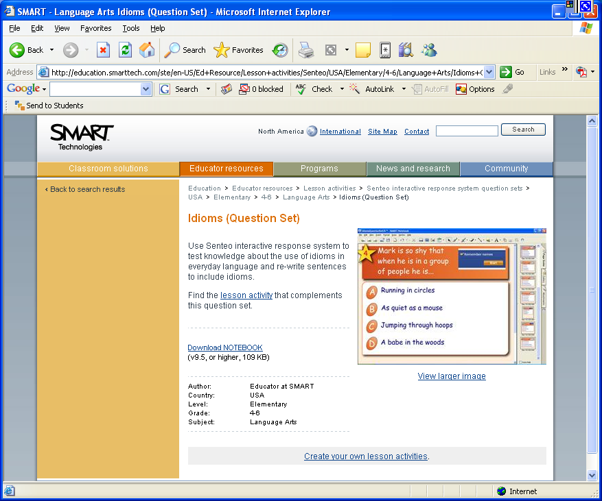

Miscellaneous Topics

Thesaurus Lesson
Grades 7-9 English by Educator at SMART
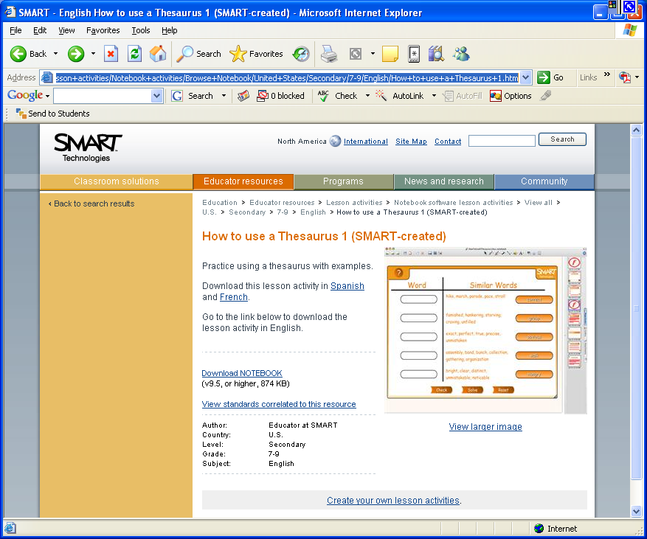

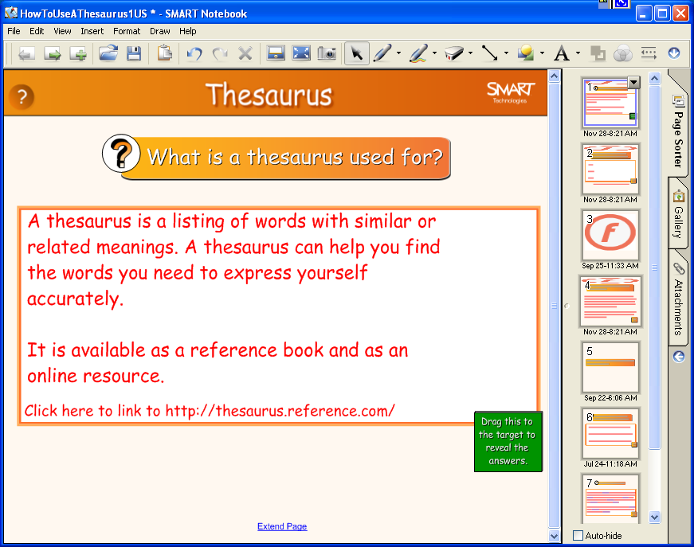

Internet Safety Lesson
http://www.netsmartz.org/


